**Server Monitoring**

Description:

Heaven Classics successfully creates an EC2 Server Instance for Windows 2022 Server. After launching the instance on the server, the next step was to monitor the operations.  
Monitoring is important to keep an eye on the performance of an EC2 instance. It helps gather data from all parts and is useful for debugging failure.  
The monitoring team at Heaven Classics started monitoring activities using the CloudWatch Service in the AWS Management Console. The Heaven Classics support team were required to meet the following objectives:

1. Check and observe the CPU utilization graph for the EC2 instance
2. Create and configure a CloudWatch alarm that sends an email notification to HCMonitor@HeavenClassics.com if the CPU utilization goes below the threshold of 3%, consecutively three times for five minutes
3. Create an IAM group named Administrator Group and attach the full administrator access policy to the group
4. Create a user for an employee of the company who requires administrator access to the company's AWS account and then add the user to the Administrator Group.

Here we are creating this requirement step by step  
  
First we need to create a EC2 machine with the name of heaven classics so go to your amazon console and search for EC2.  
  
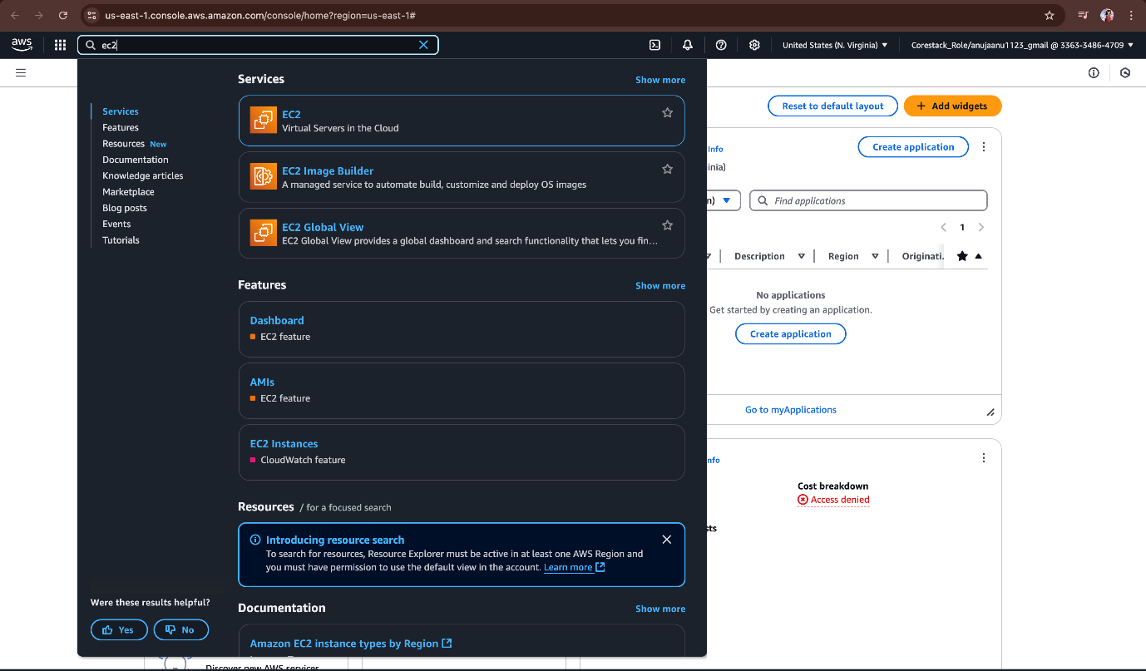  
  
And then press launch instances.  
  
Now we need to name our instance as heaven classics mentioned above in the description.  
  
And select the windows with 2022 base in application and OS image section.  
  
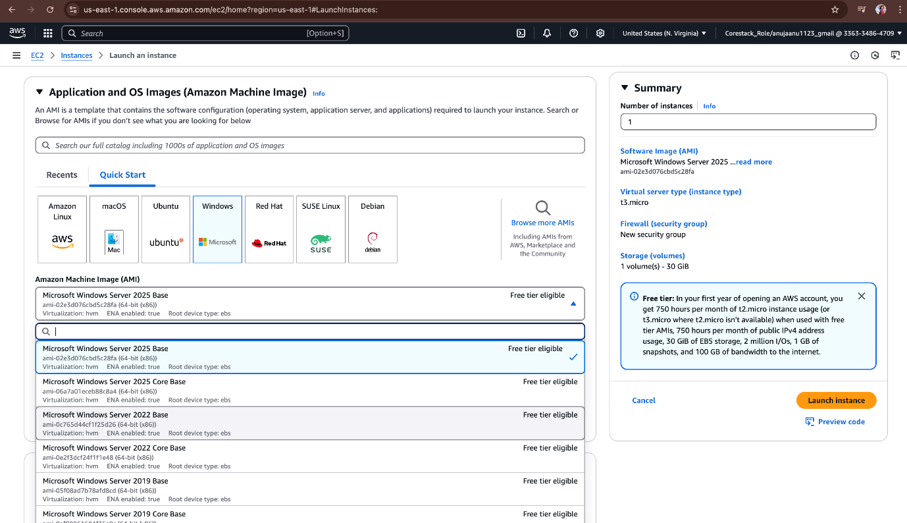  
  
And select instance type as t2.micro  
  
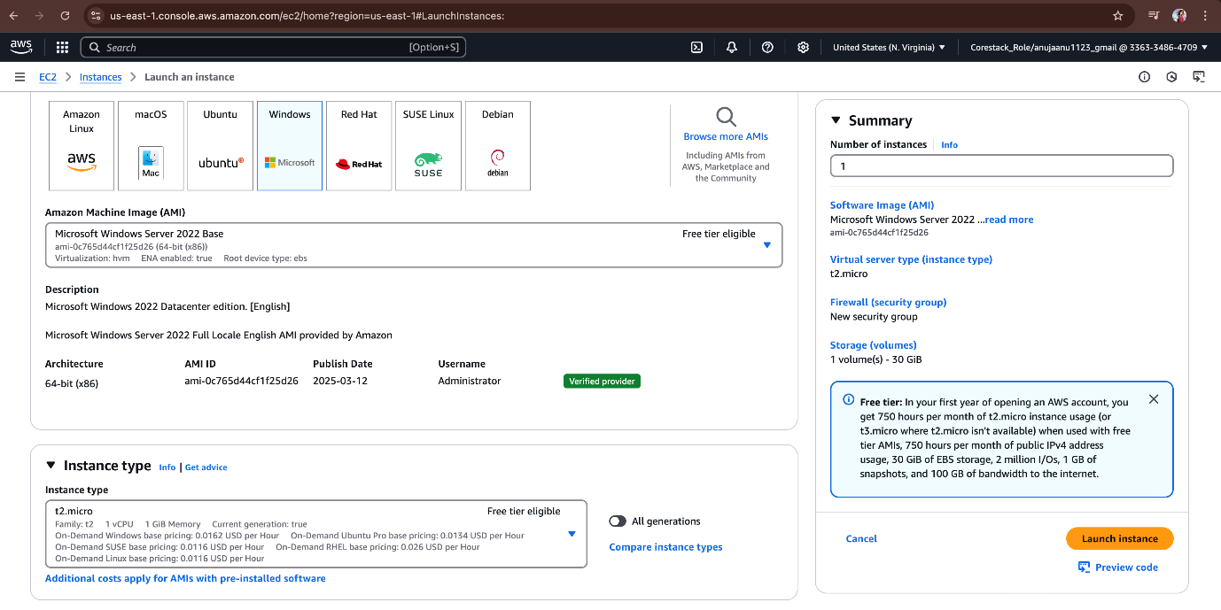  
And in keypair section select option as create new keypair.  
  
Then give your keypair a name and select .pem key to connect using open SSH. And click on create key pair.  
  
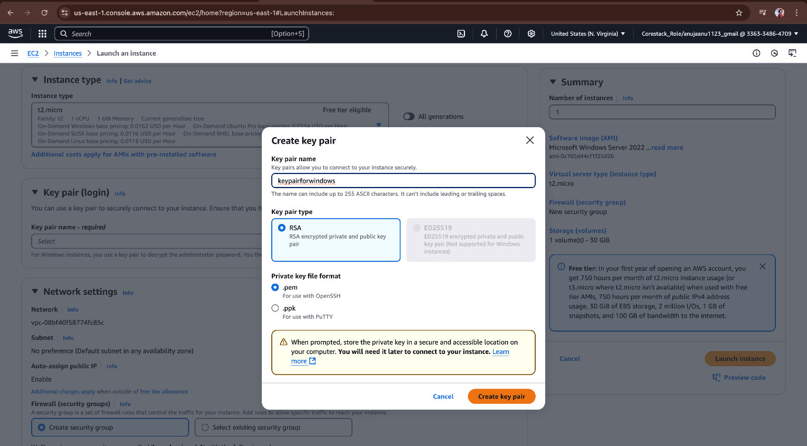  
  
In network settings keep it as default and launch Instance.  
  
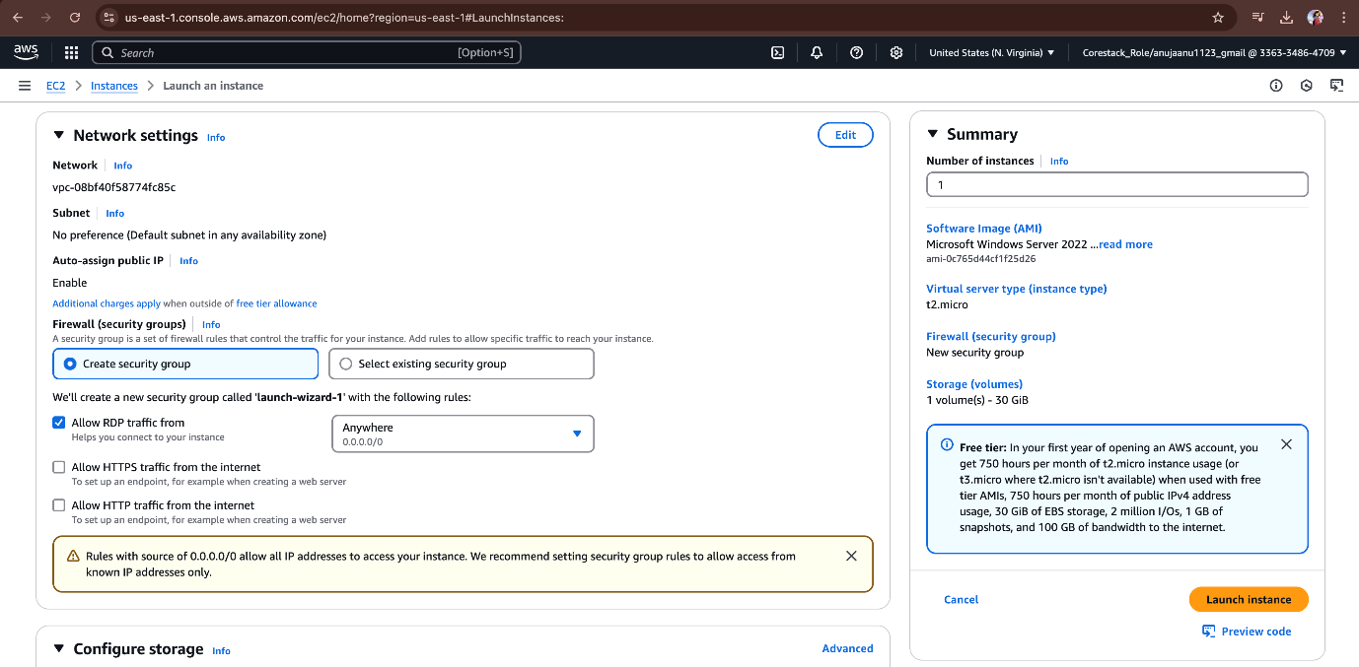  
  
After clicking on launch instance we can see our instance is creating it will take 2 to 3 mins to create our instance.  
  
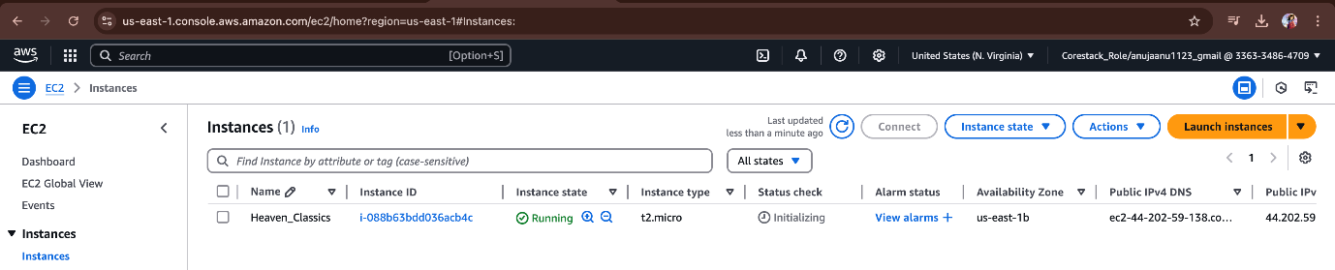  
  
  
so we can see our instance is created and upon running now.  
  
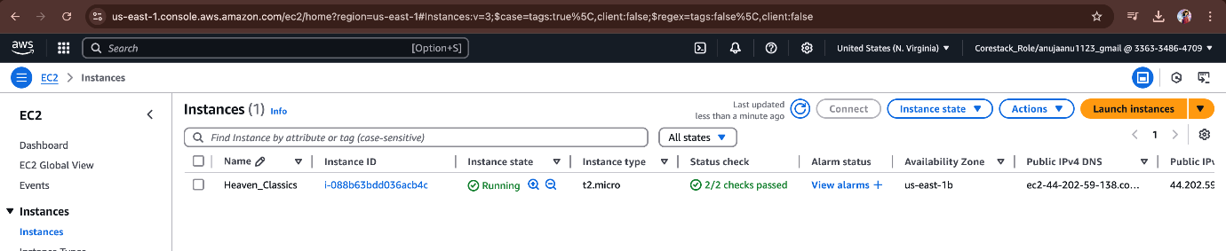  
  
And the click on instance we can see down a tab called monitoring click on that you can see the CPU utilization for our EC2 instance.  
  
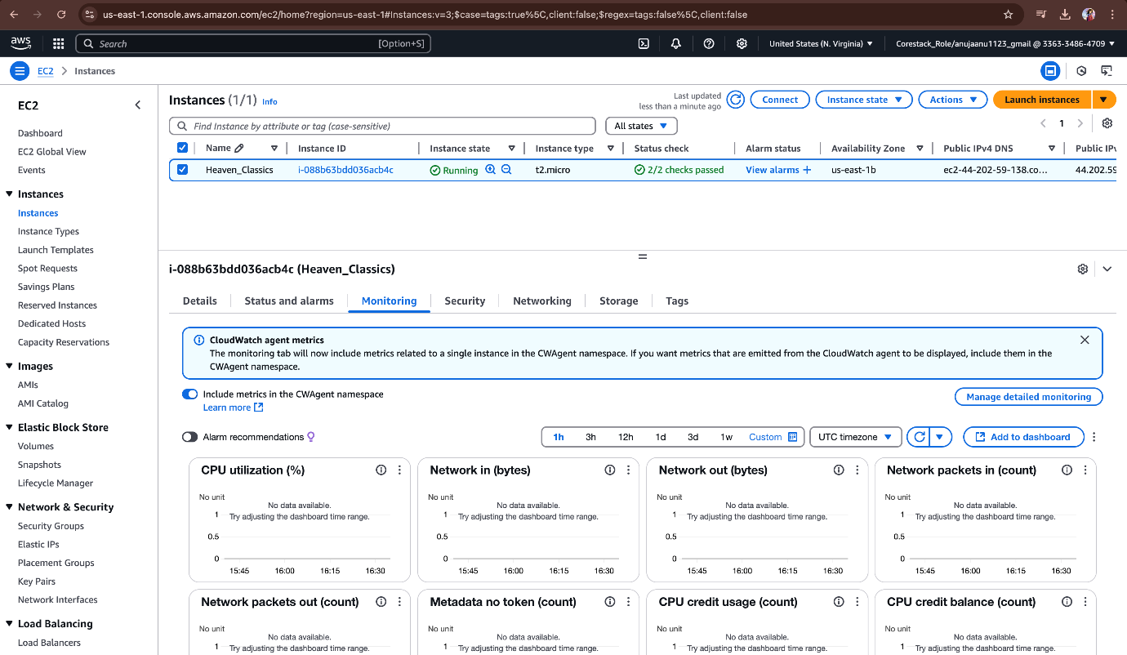  
  
**Creating cloud watch alarm:**On search bar search for cloud watch. The press enter.  
  
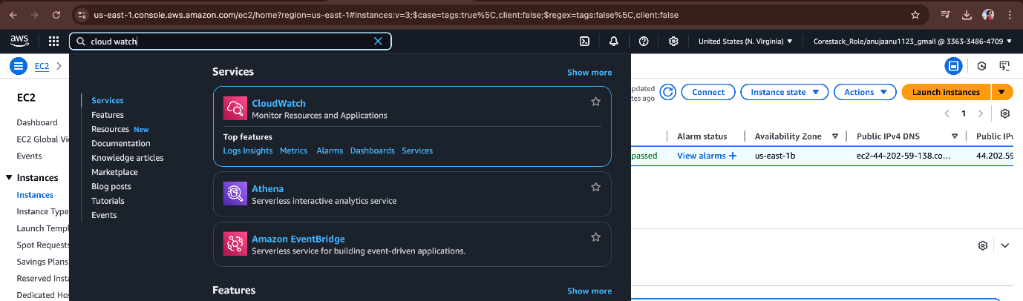  
  
Press on Alarms then press on create alarm.  
  
And specify the metrics and conditions and press on select metrics.  
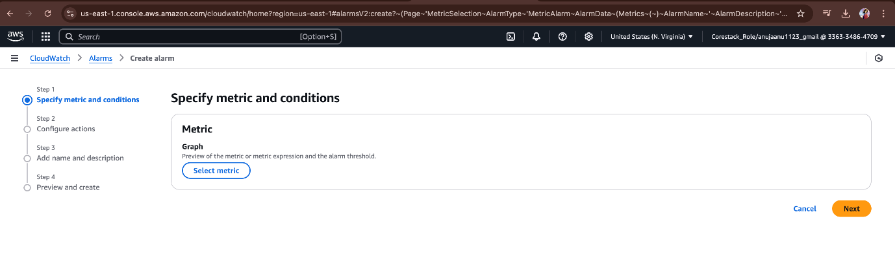  
in select metrics select EC2   
  
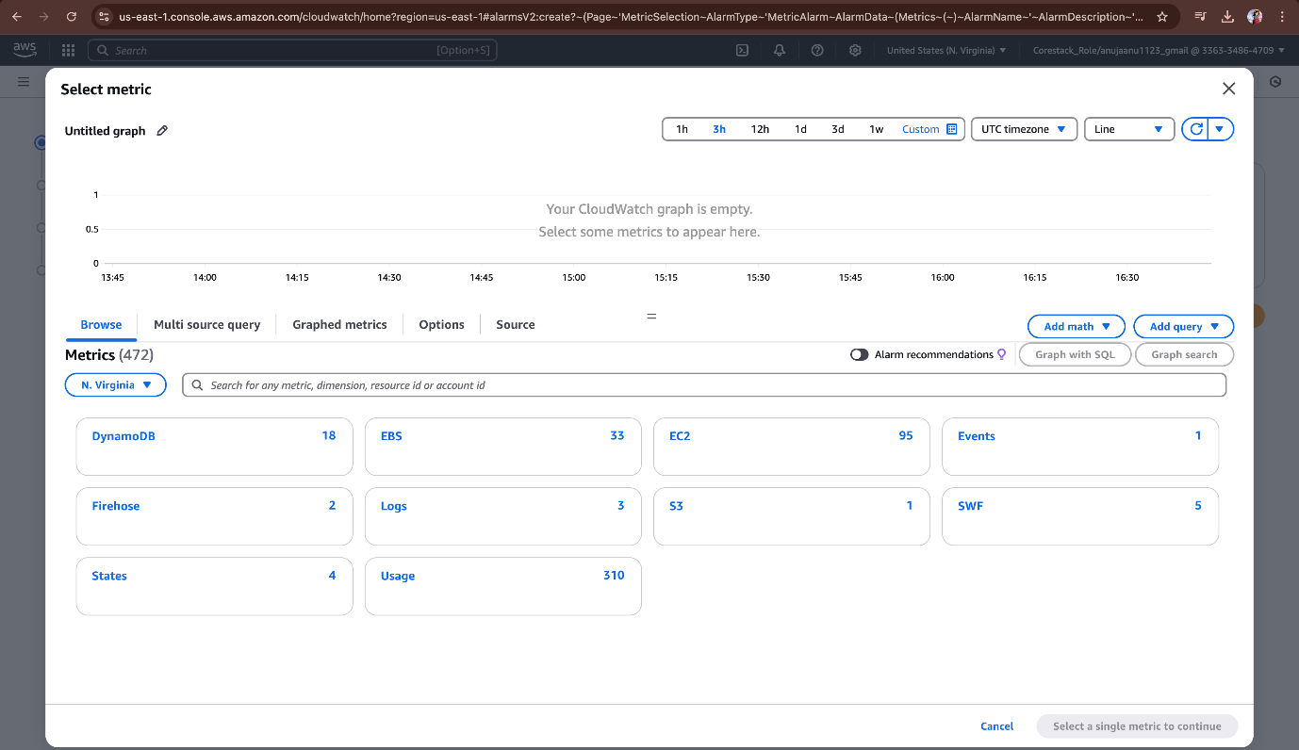  
  
  
In that select metrics select CPU utilization. And press on select metrics.   
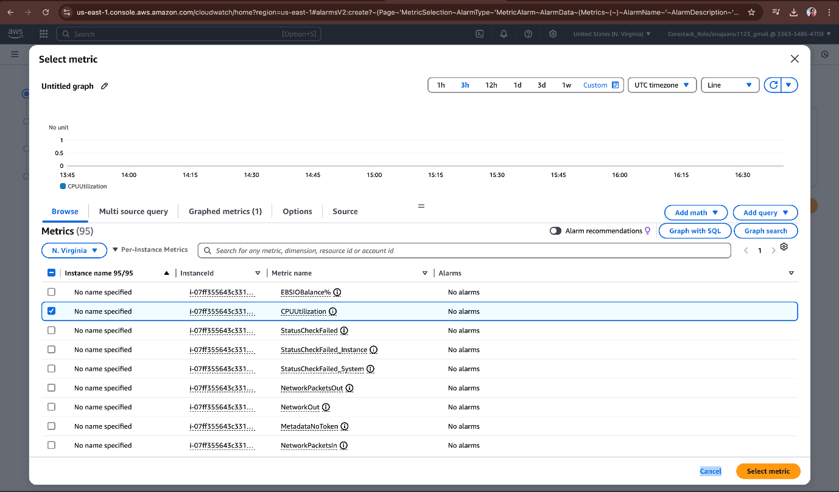  
  
Then the select metrics step will look like this  
  
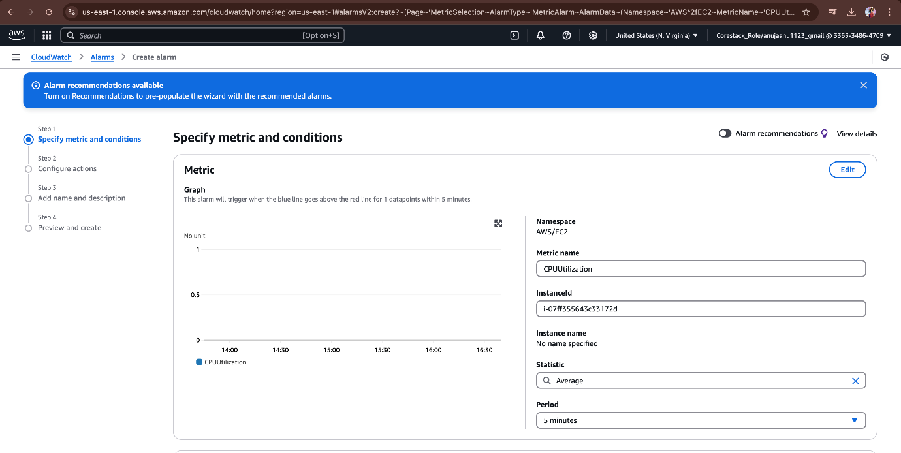  
  
And select conditions in threshold type select static and select whenever CPU utilization is greater that 3 we need to get notification. And press next,  
  
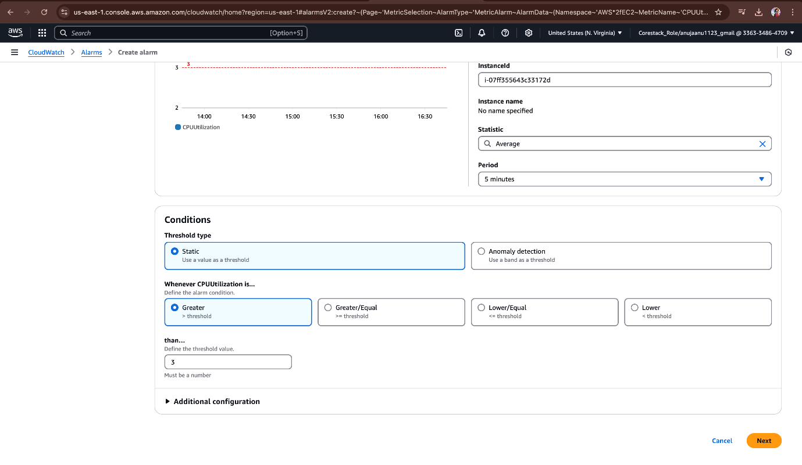  
In configuration actions select alarm state trigger in alarm and send a notification to SNS topic select as create new topic and give alarm name and give email notification as   
[HCMonitor@HeavenClassics.com](mailto:HCMonitor@HeavenClassics.com) and press on create SNS topic.  
  
And just review all the things and in additional configuration give datapoints to alarm as 3 why means in our description we have a condition like utilization goes below the threshold of 3%, consecutively three times for five minutes then we need to get email notification.  
  
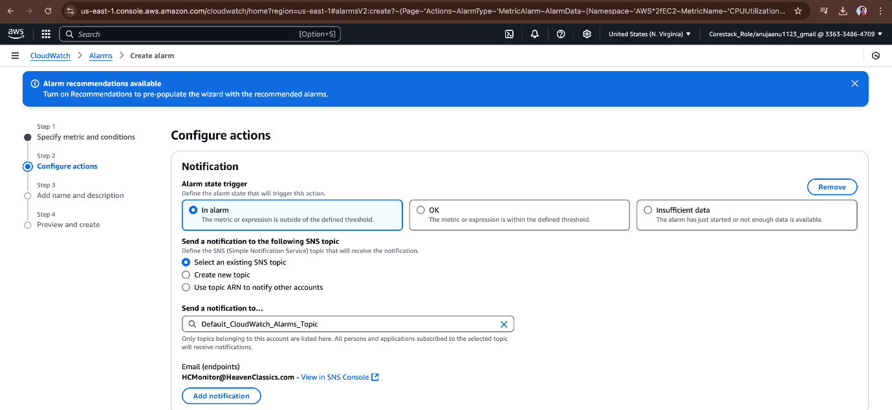  
And finally press on create alarm.  
  
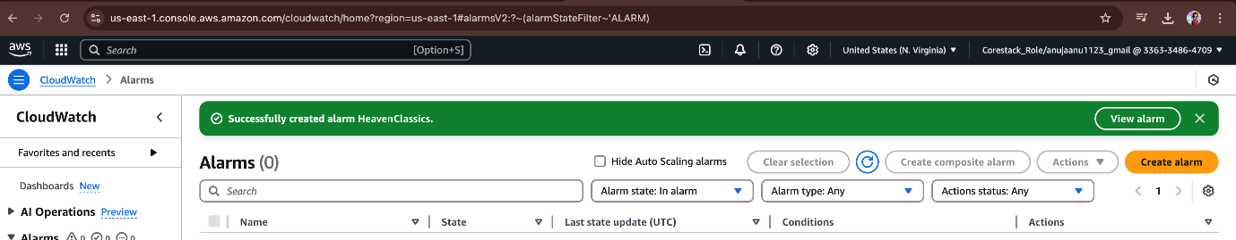  
  
Then you need to verify your email then your SNS topic will be active.  
  
**Creating a group and giving administrator access to new user in the group:**

Open AWS console and click on IAM (Identity and access management) in search bar  
  
Click on user group and create a new group.

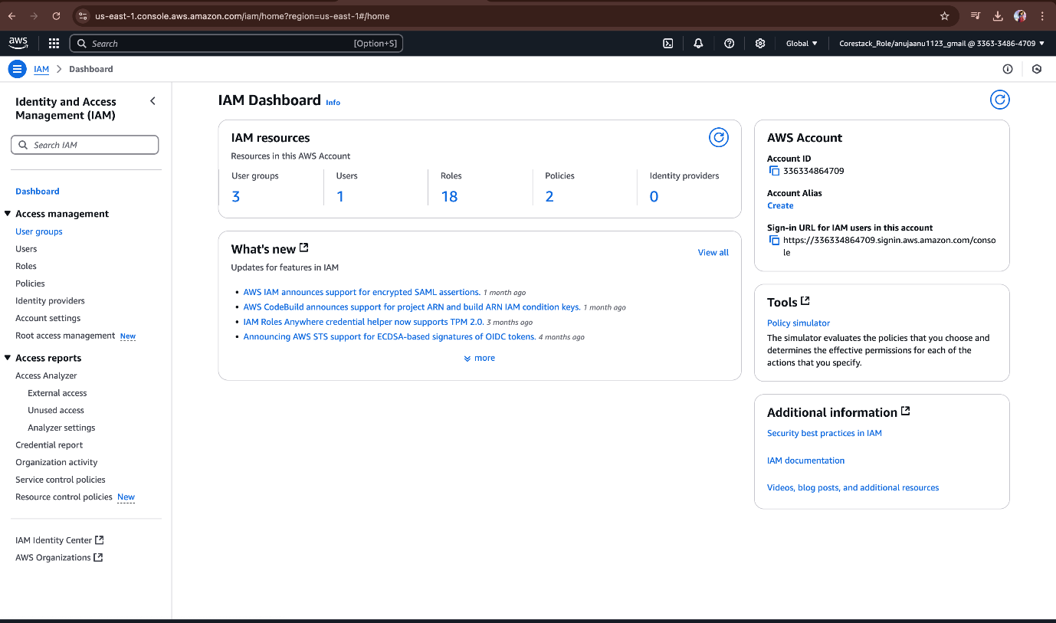  
  
And a name to your group.  
  
And in attach permission column attach permission as Administrator access it will grant full administrator access. Then click on create group.  
  
  
It will create a new group. Now we need to create a user and need to attach in that group.  
  
click on user and create user.  
  
Now we need to specify the user details like name and password after that press on next.  
  
In set permission select add user to group and select your group name which you need to add this user.  
By adding in that group our user will also get all the permissions which are there applicable for the group. And then press next.  
  
Review and create the user.  
  
After that your user name and password will visible please remember them.  
  
Finally you can able to see your user in the created and having administrator access.  
  
